**SQUARE OF NUMBER**

**EXP NO: 16**

**AIM:** To compute square of number using 8085 processor.

**ALGORITHM:**

1. Load the base address of the array in HL register pair.
2. Assign accumulator as 0.
3. Load the content of memory location specified into register.
4. Add content of memory location with accumulator and decrement register content by 01.
5. Check if register holds 00, if so store the value of accumulator in memory location.

**PROGRAM:**

LXI H,8000

XRA A

MOV B,M

LOOP: ADD M

DCR B

JNZ LOOP

STA 8001

HLT

**OUTPUT:**

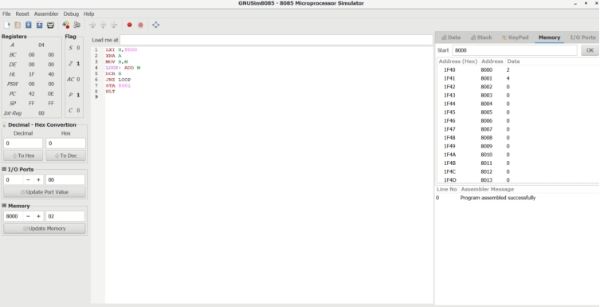

**RESULT:** Thus the program was executed successfully using 8085 processor simulator.